GUIDE HTML (by Buttolo Marco)

HTML stands for HyperText Markup Language and it is basically a markup language that is a language for creating web pages (HTML pages). To work in HTML just any ordinary text editor, such as Notepad classic windows (or pico, vi, ... if you are using linux). What's really important to be able to properly display the contents of an HTML page is to save the file with the HTML (or HTM). Usually an HTML page always presents at least the following basic structure:

<!DOCTYPE html PUBLIC "-//W3C//DTD XHTML 1.0 Strict//EN"
"http://www.w3.org/TR/xhtml1/DTD/xhtml1-strict.dtd">
<html xmlns="http://www.w3.org/1999/xhtml">
<head>
<title></title>
</head>
<body>
</body>
</html>
Let us briefly the basic structure of an HTML page. First, the first line indicates that we are using the specifications of the World Wide Web Consortium (W3C). We recognize in an HTML page consists of:

- Header (HEAD), which contains guidelines on how the document should be read and interpreted by the browser;
- A body (BODY) that contains the actual code.

Essentially based on the use of HTML tags that directives pagination of the page (the page layout directives). Each HTML tag that is opened must be closed. A tag is opened by calling it by its name and enclosing the symbols <>. For example:

<tag name>
To close a tag, there is the "/" symbol in front of the tag name. For example:

<tag name>
……..
</tag name>

Let's see what are the most commonly used tags. Let us now consider the following simple example:

<!DOCTYPE html PUBLIC "-//W3C//DTD XHTML 1.0 Strict//EN"
"http://www.w3.org/TR/xhtml1/DTD/xhtml1-strict.dtd">
<html xmlns="http://www.w3.org/1999/xhtml">
<head>
<title> Maschera di prova</title>
</head>
<body>
Prima pagina di prova!!!!!
</body>
</html>
Save the file by calling the whole test1.html, and to test the outcome just open any browser (internet explorer, mozilla firefox, ...). The result is as follows:
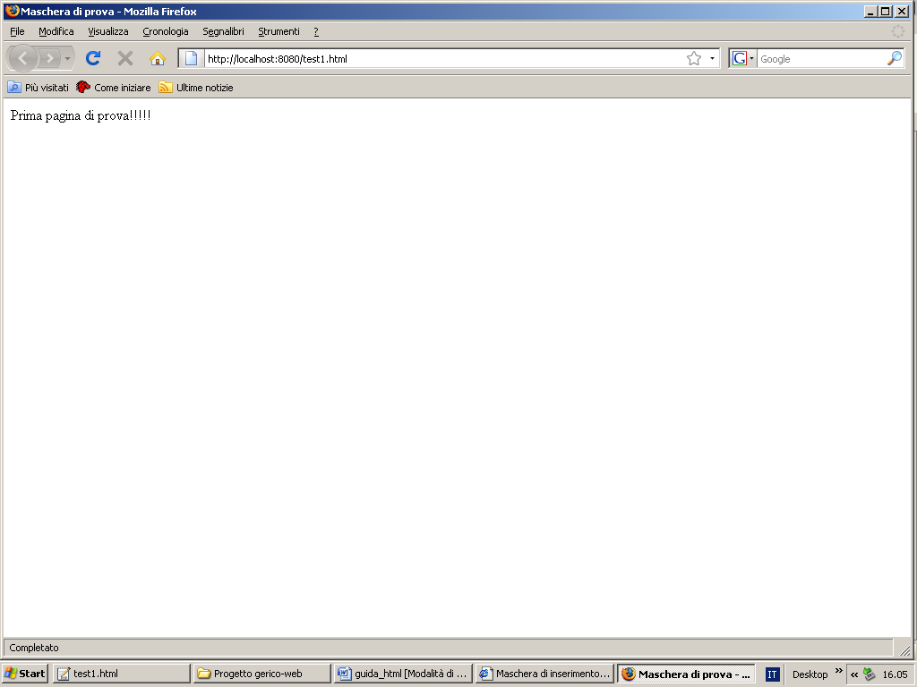
Picture 1

As can be seen easily from the figure "screen test" is the title of the window. This thing is specified by the <TITLE>. Inside the body of the web page identified by <BODY> you can write down everything that appears on the screen. The body must be enclosed within the HTML page specified by the HTML tag. The <HEAD> specify everything that should be within the header of the HTML page (including of course the title). Now let's see another example a little 'more complex where you write a little' bold, italic and underlined.

<!DOCTYPE html PUBLIC "-//W3C//DTD XHTML 1.0 Strict//EN"
"http://www.w3.org/TR/xhtml1/DTD/xhtml1-strict.dtd">
<html xmlns="http://www.w3.org/1999/xhtml">
<head>
<title>Secondo esempio</title>
</head>
<body>
<I> Testo in corsivo </I><br>
<B> Testo in grassetto </B><br>
<u> Testo sottolineato </u>
</body>
</html>

Please pay attention now to the fact that the names of the tags, there is no difference between uppercase or lowercase. The system is not case-sensitive. Tagged with <I> you can write text in italics, with the tag <B> you can write text in bold, while the <U> tag you can write text with underlining. Always remember to close an open tag.
The tag <BR> allows the carriage return.
The result of the previous example is as follows:

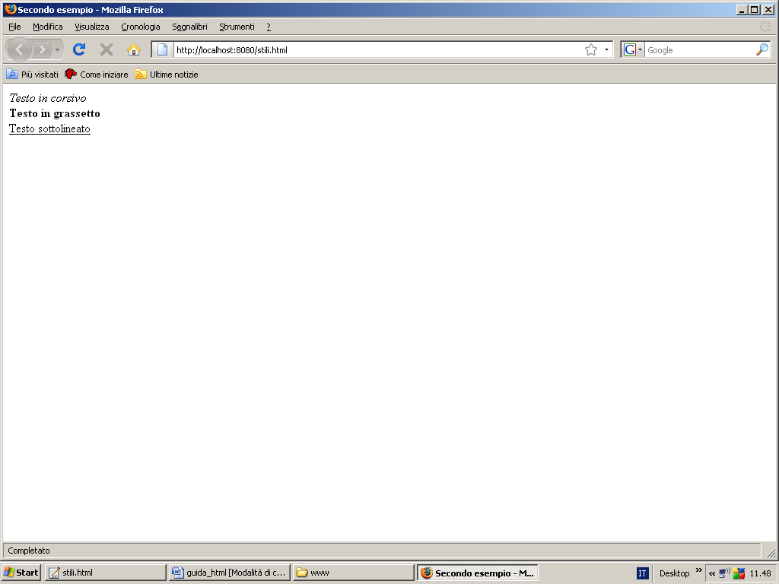
Picture 2

Another example is the alignment of the text. Tagged with <CENTER> you can center a message on the browser window. For example:

<!DOCTYPE html PUBLIC "-//W3C//DTD XHTML 1.0 Strict//EN"
"http://www.w3.org/TR/xhtml1/DTD/xhtml1-strict.dtd">
<html xmlns="http://www.w3.org/1999/xhtml">
<head>
<title>Esempio di testo centrato</title>
</head>
<body>
<center>Testo centrato</center>
</body>
</html>

The following figure shows the example just described:

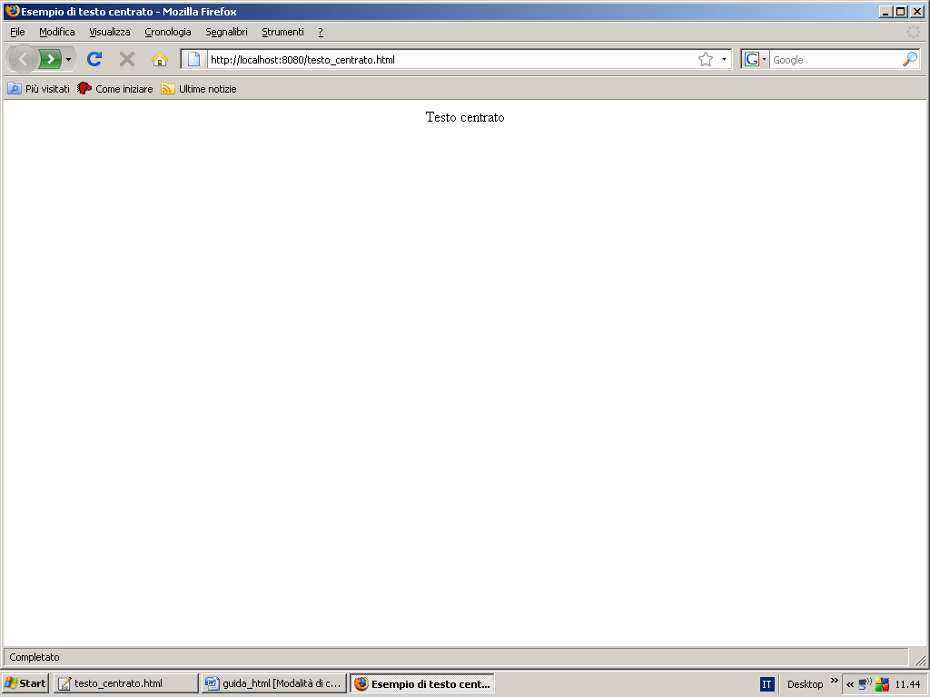
Picture 3

Now suppose we want to write a text blinking green. Through the following HTML code you can do this:

<!DOCTYPE html PUBLIC "-//W3C//DTD XHTML 1.0 Strict//EN"
"http://www.w3.org/TR/xhtml1/DTD/xhtml1-strict.dtd">
<html xmlns="http://www.w3.org/1999/xhtml">
<head>
<title>Testo verde lampeggiante</title>
</head>
<body text="green">
<center><blink>Testo verde lampeggiante!!!</blink></center>
</body>
</html>

Therefore, using the tag <BLINK> you can make blinking text. Let us now briefly how you can resize a text string. Analyze briefly the following sample code:

<!DOCTYPE html PUBLIC "-//W3C//DTD XHTML 1.0 Strict//EN"
"http://www.w3.org/TR/xhtml1/DTD/xhtml1-strict.dtd">
<html xmlns="http://www.w3.org/1999/xhtml">
<head>
<title>Seconda pagina di esempio</title>
</head>
<body>
<H1>PRIMA FRASE</H1>
<H2>SECONDA FRASE</H2>
<H3>TERZA FRASE</H3>
<H4>QUARTA FRASE</H4>
<H5>QUINTA FRASE</H5>
<H6>SESTA FRASE</H6>
</body>
</html>

The result is the following:

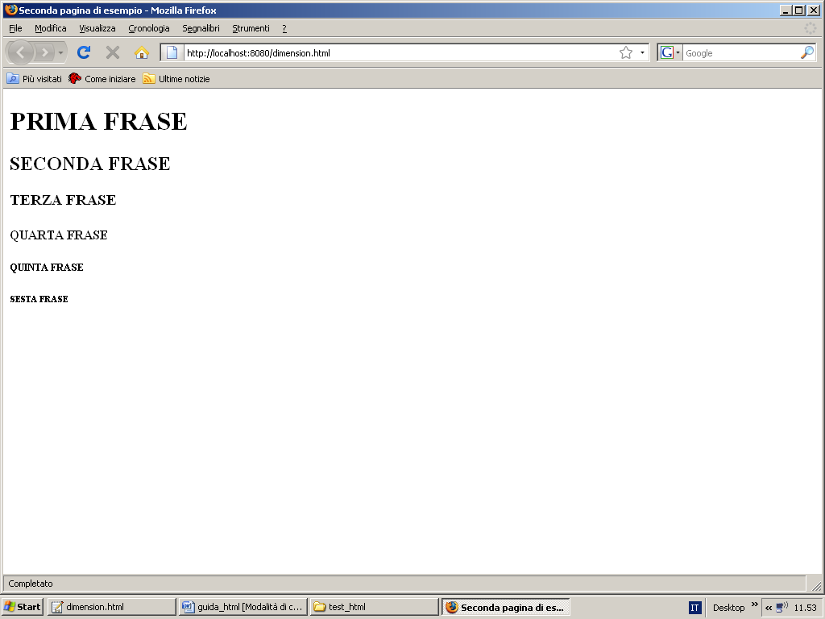
Picture 4

These tags (h1, h2, h3, h4, h5, h6) allow you to print text in various sizes, from the highest level (h1), lower (h6). Let us now look in HTML as you can create a list of items. First, a list can be of two types:

- ordered list
- Unordered list

Let's see an illustrative example of ordered list. See about the following example:

<!DOCTYPE html PUBLIC "-//W3C//DTD XHTML 1.0 Strict//EN"
"http://www.w3.org/TR/xhtml1/DTD/xhtml1-strict.dtd">

<html xmlns="http://www.w3.org/1999/xhtml">
<head>
<title>Esempio elenco ordinato</title>
</head>
<body>
<ol>
<li>primo elemento</li>
<li>secondo elemento</li>
<li>terzo elemento</li>
</ol>
</body></html>
Graphically we have:

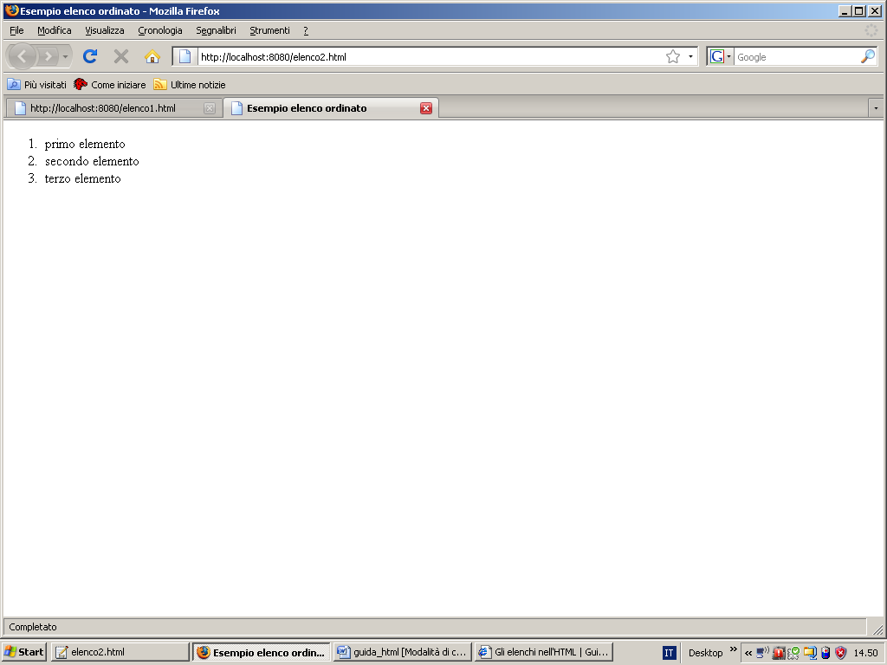
Picture 5
So through <ol> in combination with the <li> you can create an ordered list. In particular, the <ol> allows you to create an ordered list, while the <li> allows you to add items as elements of the list. To create an unordered list instead just follow the following example:

<!DOCTYPE html PUBLIC "-//W3C//DTD XHTML 1.0 Strict//EN"
"http://www.w3.org/TR/xhtml1/DTD/xhtml1-strict.dtd">
<html xmlns="http://www.w3.org/1999/xhtml">
<head>
<title>Esempio elenco non numerato.</title>
</head>
<body>
<ul>
<li>Primo</li>
<li>Secondo</li>
<li>Terzo</li>
</ul>
</body>
</html>
Of course you can create a list not ordered through the special tag <ul>. Briefly <ol> stands for ordered list, the <li> stands for list item, while <ul> stands for unordered list. Below is shown the unordered list built with the previous HTML code:
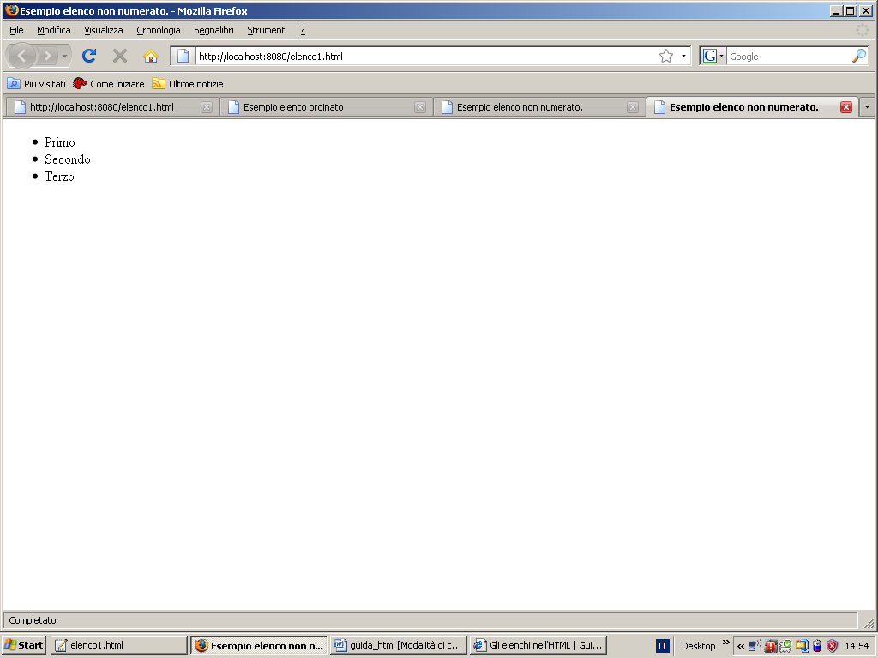
Picture 6
Let's look at an example a little 'more complete where they are used all the tags seen so far.

<!DOCTYPE html PUBLIC "-//W3C//DTD XHTML 1.0 Strict//EN"
"http://www.w3.org/TR/xhtml1/DTD/xhtml1-strict.dtd">

<html xmlns="http://www.w3.org/1999/xhtml">
<head>
<title>Esempio completo con elenchi</title>
</head>

<body>
<center>
Esempi di liste
</center>
<br><br><br>
Qui di seguito è presente una raccolta di liste utili:
<br>
<ol>
<li>Primo termine.</li>
<li>Secondo termine.</li>
<li>Terzo termine.</li>
</ol>
<ul>
<li><b><blink>Primo termine.</b></blink></li>
<li><i>Secondo termine.</i></li>
<li><u>Terzo termine.</u></li>
</ul>
</body>
</html>

In this example, you create a web page with a title, the main message center, and two lists:
1. An ordered list of three items;
2. An unordered list still consists of three voices, but with one different from the other three items.
In fact, the first item ordered is not bold text and flashing, the second item in the list is a string written in italics, while the third item is a string written with an underline.
The following figure shows the web page you just created:

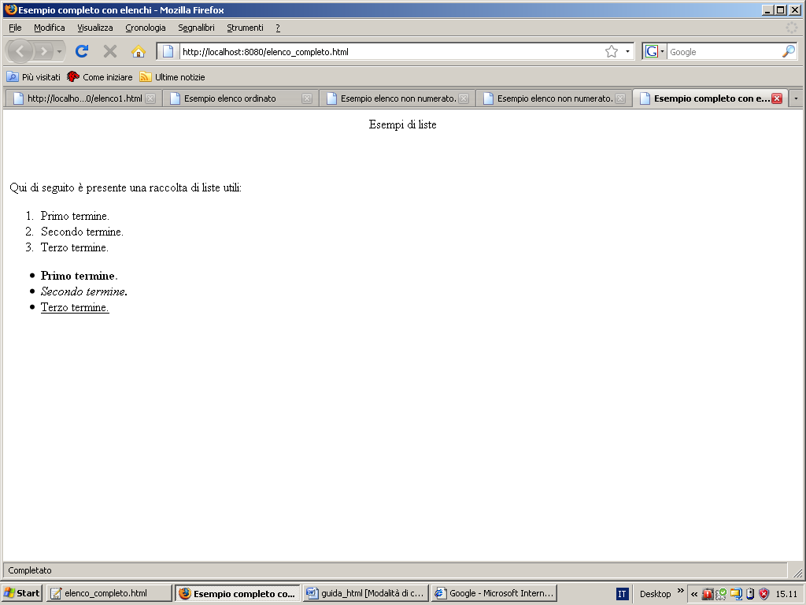
Picture 7

Now let's see a web page a bit 'more complex. This page introduces other types of lists, and introduces a very important concept: the table.

<!DOCTYPE html PUBLIC "-//W3C//DTD XHTML 1.0 Strict//EN"
"http://www.w3.org/TR/xhtml1/DTD/xhtml1-strict.dtd">
<html xmlns="http://www.w3.org/1999/xhtml">
<head>
<title></title>
</head>
<body>
<br>
<center> Esempio di semplice tabella </center>
<br><hr><br>
<table>
<tr>
<td>
<ol>
<li> Primo termine.</li>
<li> Secondo termine.</li>
<li> Terzo termine.</li>
</ol>
</td>
<td>
<ul>
<li>Primo termine.</li>
<li>Secondo termine.</li>
<li>Terzo termine.</li>
</ul>
</td>
</tr>
<tr>
<td>
<ol type="a">
<li>Primo termine.</li>
<li>Secondo termine.</li>
<li>Terzo termine.</li>
</ol>
</td>
<td>
<ol type="i">
<li>Primo termine.</li>
<li>Secondo termine.</li>
<li>Terzo termine.</li>
</ol>
</td>
</tr>
<tr>
<td>
<ol type="I">
<li>Primo termine.</li>
<li>Secondo termine.</li>
<li>Terzo termine.</li>
</ol>
</td>
<td>
<ul type="circle">
<li>Primo termine.</li>
<li>Secondo termine.</li>
<li>Terzo termine.</li>
</ul>
</td>
</tr>
<td>
<td>
<ul type="square">
<li>Primo termine.</li>
<li>Secondo termine.</li>
<li>Terzo termine.</li>
</ul>
</td>
<tr>
</tr>
</table>
</body>
</html>

In this code you will immediately notice the presence of new tags. First, <hr> allows you to draw a horizontal line on the screen. The <table> allows players to create a table with a certain number of rows and a bunch of columns. Columns are specified by the <td> and rows are specified using the <tr>. So far we have mentioned the various tag without specifying that they may possess certain attributes. An attribute in a tag can be specified as follows:
<name tag list attributes>
In the code on the previous page, the type attribute in <ol> <ul> and allows you to specify which font to use to define the list. So if you want to define a list of characters instead of numbers in an ordered list, simply write this line of code:

<ol type=”a”>

And that's it. As we shall see, the tables apply very much, in so far as they can be formatted appropriately the layout of a web page and make the graphics much more appealing. The result of the HTML code just described is shown below:

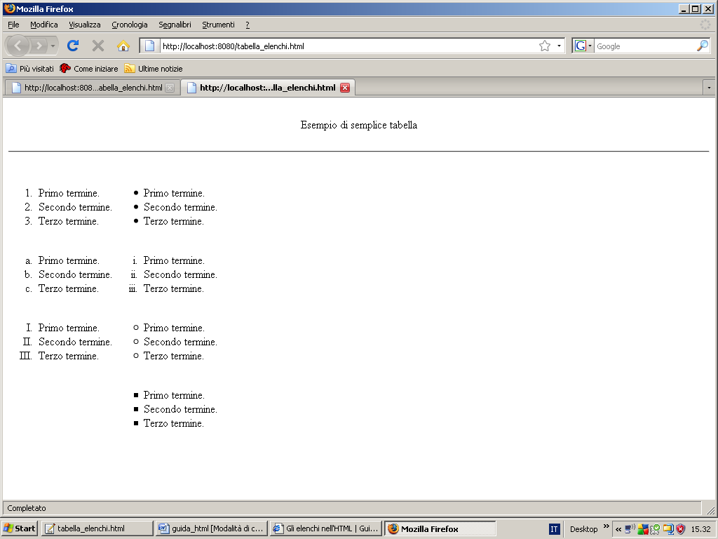
Picture 8

Let us now clarify how to use tables. First, a table can be made ​​more clearly by rows and multiple columns. For example, suppose you want to build a table with 2 rows and 3 columns. Remembering that with the tag <td> you specify the columns and with the tag <tr> rows, we have:

<!DOCTYPE html PUBLIC "-//W3C//DTD XHTML 1.0 Strict//EN"
"http://www.w3.org/TR/xhtml1/DTD/xhtml1-strict.dtd">
<html xmlns="http://www.w3.org/1999/xhtml">

<head>
<title>Esempio di tabella</title>
</head>
<body>
<center>
<table>
<tr>
<td>
A
</td>
<td>
B
</td>
<td>
C
</td>
</tr>
<tr>
<td>
E
</td>
<td>
F
</td>
<td>
G
</td>
</tr>
</table>
</center>
</body>
</html>
The example is shown below:
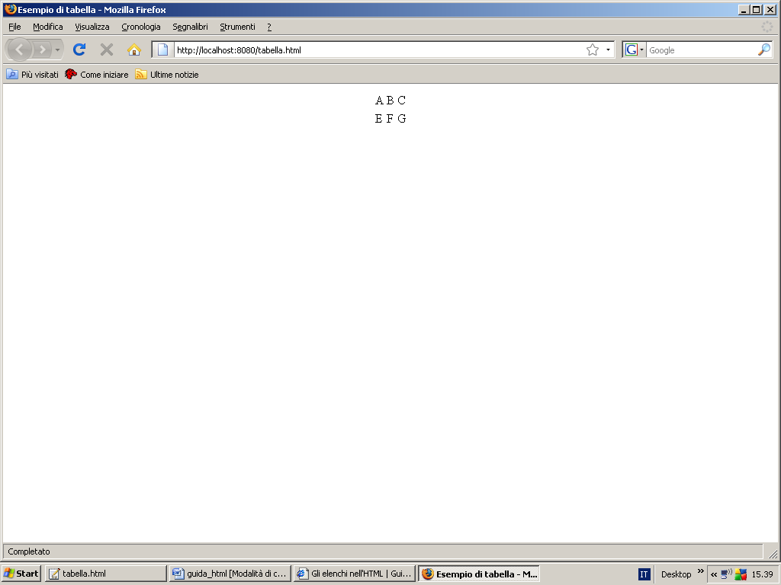
Picture 9
But if we want to make visible the table, that we want to provide a visible broth, just add to <table> the border attribute, as shown below:

<!DOCTYPE html PUBLIC "-//W3C//DTD XHTML 1.0 Strict//EN"
"http://www.w3.org/TR/xhtml1/DTD/xhtml1-strict.dtd">
<html xmlns="http://www.w3.org/1999/xhtml">
<head>
<title>Esempio di tabella</title>
</head>
<body>
<center>
<table border=1>
<tr>
<td>
A
</td>
<td>
B
</td>
<td>
C
</td>
</tr>
<tr>
<td>
E
</td>
<td>
F
</td>
<td>
G
</td>
</tr>
</table>
</center>
</body></html>
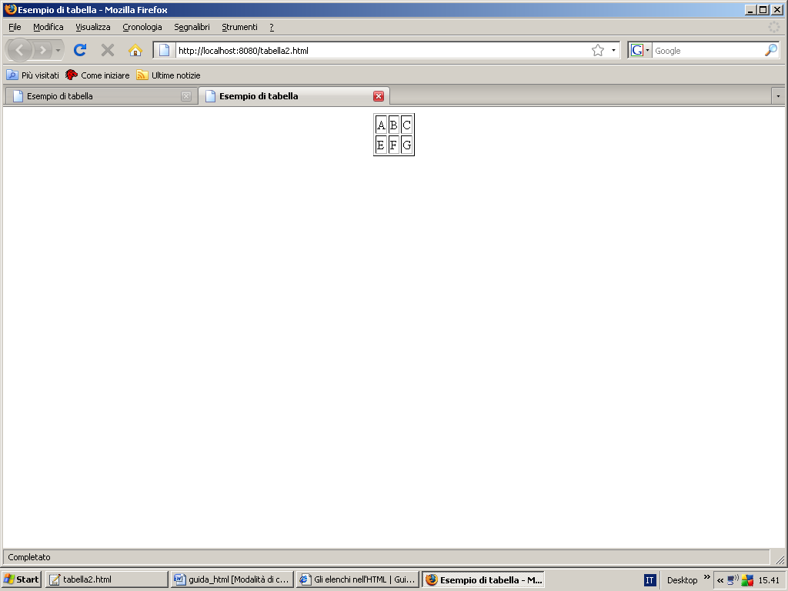
Picture 10
Often, when you browse the Internet, happen to have open a web page by simply clicking on an image or a word. Click on, for example, on a word opens a new web page. This is done by simply creating a link (in English link) with the web page (HTML) that you want to open. Let's see the following piece of HTML code:

<!DOCTYPE html PUBLIC "-//W3C//DTD XHTML 1.0 Strict//EN"
"http://www.w3.org/TR/xhtml1/DTD/xhtml1-strict.dtd">
<html xmlns="http://www.w3.org/1999/xhtml">
<head>
<title>Esempio di link</title>
</head>
<body>
<center>
Testo senza link
</center>
<br><br><hr>
<center>
<a href="prova.html">Testo con link </a>
</center>
</body>
</html>

The tag fundamental in order to perform such a link is represented by <a href…> Text </ a>. In a few words between the quotes of the href attribute of the tag <a> is specified the file name or the path (relative or absolute) with the name of the file you want to open, while in the <a> is no Text you want to make dockable that is linkable.

The example is shown below:
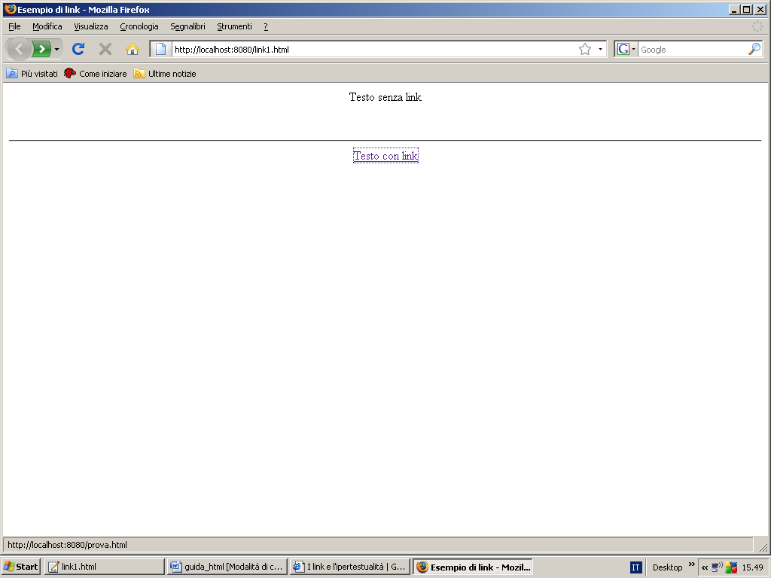
Picture 11

The following example shows how to use the service instead MAILTO to send e-mail. MAILTO is essentially a particular link, a service that allows the browser to open the e-mail service.

<!DOCTYPE html PUBLIC "-//W3C//DTD XHTML 1.0 Strict//EN"
"http://www.w3.org/TR/xhtml1/DTD/xhtml1-strict.dtd">
<html xmlns="http://www.w3.org/1999/xhtml">
<head>
<title>Esempio utilizzo mail</title>
</head>

<body>
<a href="mailto:prova@libero.it">
Invio mail
</a>.
</body>
</html>

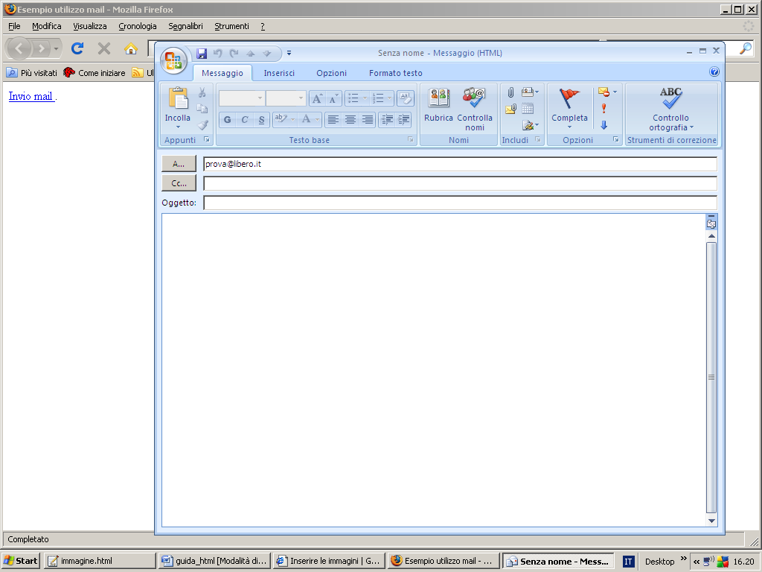
Picture 12

Often, navigating through the various web pages of the Internet, to find buttons or images (animated or not) clickable or not. The following snippet of HTML code, just allows you to insert a button.

<!DOCTYPE html PUBLIC "-//W3C//DTD XHTML 1.0 Strict//EN"
"http://www.w3.org/TR/xhtml1/DTD/xhtml1-strict.dtd">
<html xmlns="http://www.w3.org/1999/xhtml">
<head>
<title>Esempio caricamento immagine</title>
</head>
<body>
<br><br>
<center>
<img src="bottone.bmp">Immagine</img>
</center>
<br><br><hr>
<center>
<a href="prova.html"><img src="bottone.bmp">Immagine cliccabile</img></a>
</center>
</body>
</html>
As can be seen easily through the link <img> you can display an image on the web page (ie BMP Bitmap, GIF or JPEG). With the SRC attribute specifies the name of the image file and / oil path in which it is located.
The following is an example:

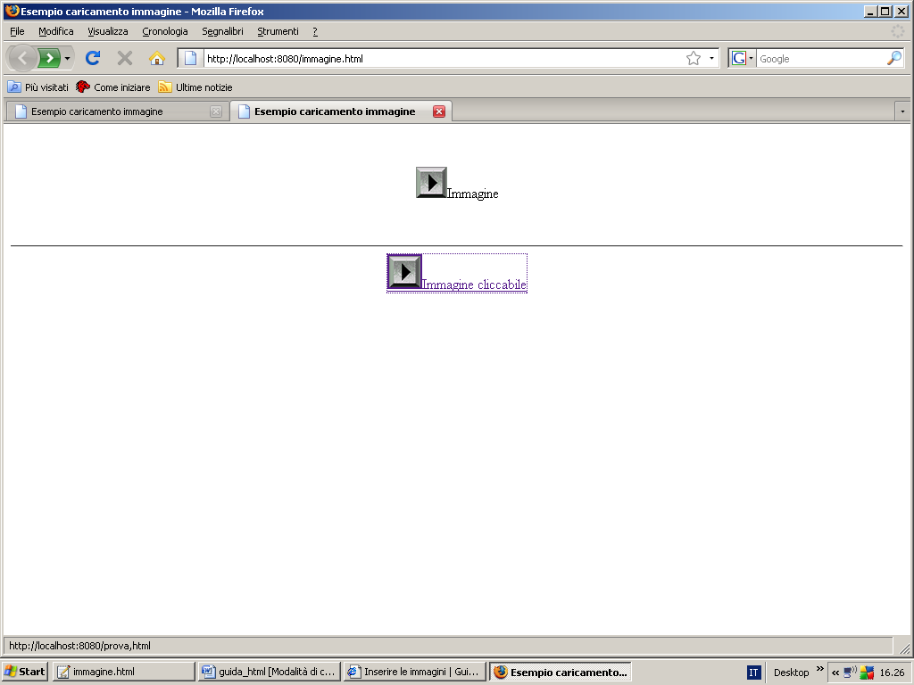
Picture 13
It is worth mentioning that ALT attribute allows you to display alternative text if no image is displayed. The following line of code shows this:

<img src=”nome immagine” ALT=”testo alternativo”></img>
Analizziamo ora brevemente il seguente codice HTML:
<!DOCTYPE html PUBLIC "-//W3C//DTD XHTML 1.0 Strict//EN"
"http://www.w3.org/TR/xhtml1/DTD/xhtml1-strict.dtd">
<html xmlns="http://www.w3.org/1999/xhtml">
<head>
<title></title>
</head>

<body>
<br><br><hr>
<!-- creazione tabella con una riga e due colonne-->
<table align="right" border=1>
<tr>
<td>
Primo elemento
</td>
<td>
Secondo elemento
</td>
</tr>
</table>
<br><br>
<hr>
</body>
</html>
First, we see immediately that the <table> has a new attribute called ALIGN. This attribute allows alignment (in this case the table) to the right (in English right). If you wanted to align to the left the table was enough to write ALIGN = "left". Pay special attention to the fact that HTML is not case-sensitive, for example write:

align=”right” oppure ALIGN=”RIGHT”
is the same thing. Also note the presence of a comment in the HTML. In the HTML comments are written like this:

<!--commento -->

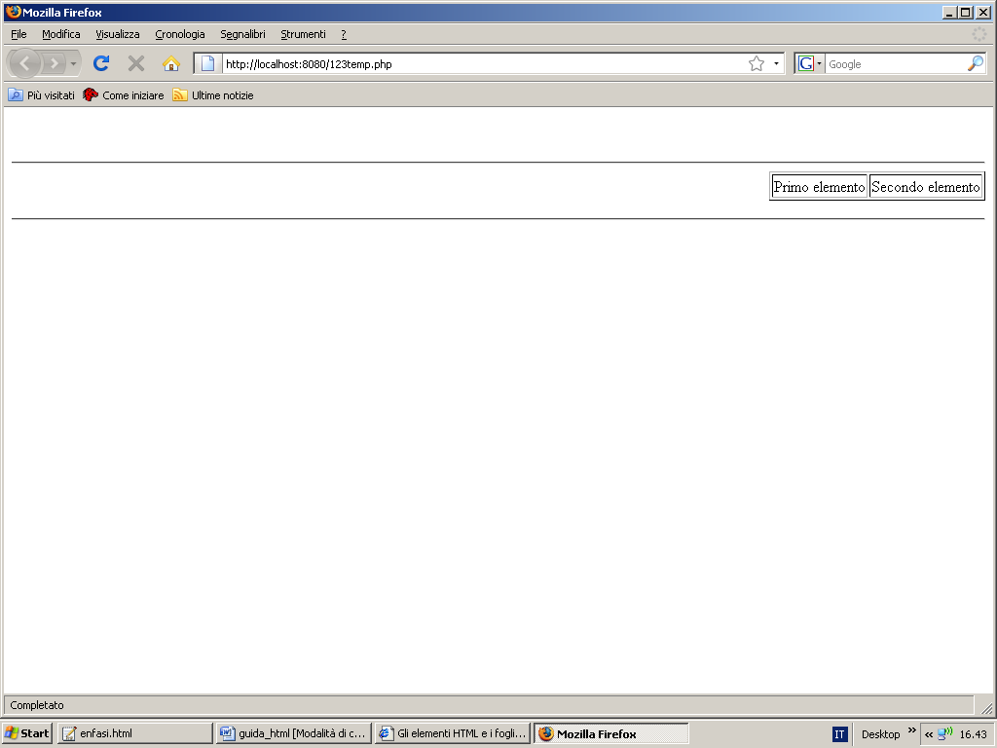
Picture 14

So far we have seen web pages without color. It 'can, however, provide a background color of the page, in order to make itself more beautiful. Let's see an example:

<!DOCTYPE html PUBLIC "-//W3C//DTD XHTML 1.0 Strict//EN"
"http://www.w3.org/TR/xhtml1/DTD/xhtml1-strict.dtd">
<html xmlns="http://www.w3.org/1999/xhtml">
<head>
<title>Esempio con sfondo</title>
</head>
<body background="sfondo.jpg" text="white">
Pagina con sfondo
</body>
</html>
Graphically we have:

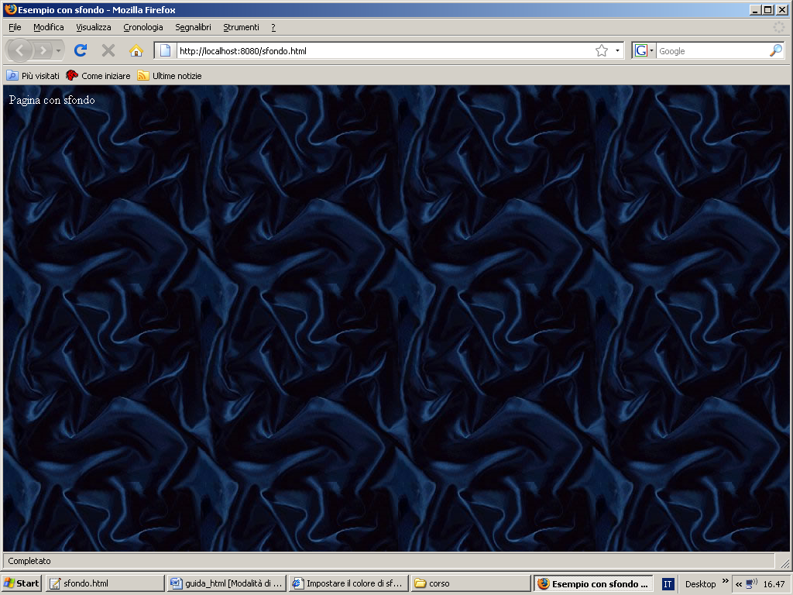
Picture 15
The color of the text was made ​​white to make it easily readable. So the background attribute in <body> allows you to specify the color of the background must have. E 'can be loaded as a background image (as we did in this case) or wire directly a color. The wiring is done by inserting background in the attribute of the tag number, in hexadecimal, of its color that you want to install. For example, if you want the color gray, then writes:

<BODY background=”#808080”>

The following table shows hexadecimal values for each specific color. See the following link:

http://www.asciitable.it/colorihtml.asp
It 'also possible, in HTML, set the language for the web page to be displayed, using the following line of code:

<body lang="it">
This creates a web page in Italian. Now consider the following example:

<html xmlns="http://www.w3.org/1999/xhtml">
<head>
<title></title>
</head>
<body>
</body>
<table width="430" border="1" bordercolor="#808080">
<tr>
<td width="30%">&nbsp;</td>
<td width="30%">&nbsp;</td>
<td width="30%">&nbsp;</td>
</tr>
<tr>
<td>&nbsp;</td>
<td colspan="2" align="center" valign="middle">
<b>&lt;td colspan=&quot;2&quot;&gt;</b>
</td>
</tr>
</table>
</html>

In this code there are some new features. First, you create a table with a width of 430 (the width attribute allows you to specify precisely the width of the table). Of course you can specify the width in pixels or as a percentage of the total size of the browser window. With the special character is possible to simulate a blank space. Using the colspan attribute you can create cells that span multiple columns. In this case it creates a cell that occupies two columns. The same is true if you want to create cells that span multiple lines. In the latter case, with the attribute rowspan you can do this. The following code snippet shows precisely what has just been said:

<table>
<tr>
<td rowspan=2>
</td>
</tr>
</table>

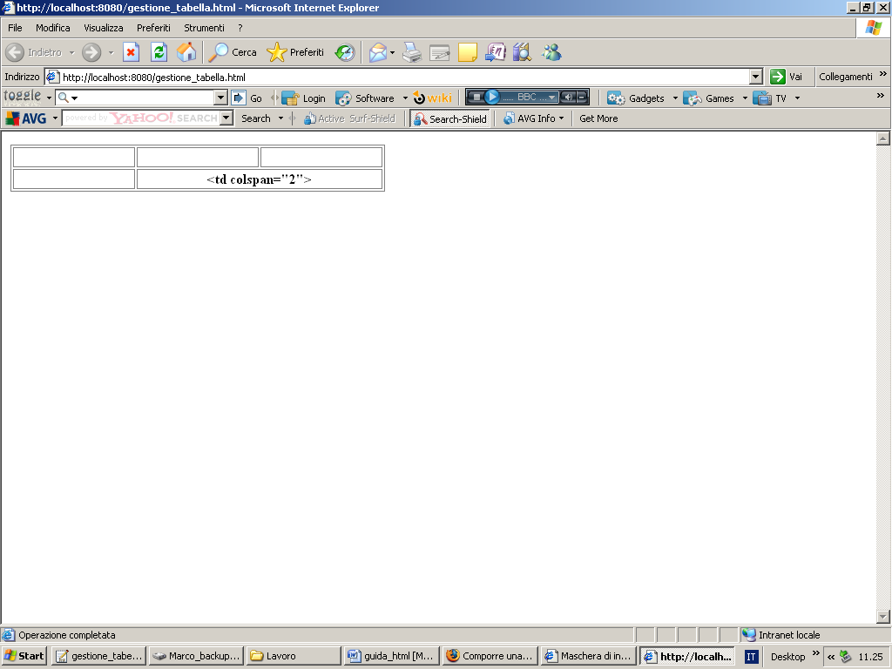
Picture 16

Another fundamental concept in HTML is the concept of frame. Essentially a frame is no more than a block, a rectangle where you can insert images, HTML content, and so on. In order to use a frame must use the tag <frameset> as shown below:

<!DOCTYPE HTML PUBLIC "-//W3C//DTD HTML 4.01 Frameset//IT" "http://www.w3.org/TR/html4/frameset.dtd">
<html>
<head>
<meta http-equiv="Content-Type" content="text/html; charset=iso-8859-1">
<title>HTML.it</title>
</head>

<frameset rows="50%,50%" cols="50%, 50%">
<frame src="frame1.html">
<frame src="frame1.html">
<frame src="frame1.html">
<frame src="frame1.html">
</frameset>
</html>
This example is shown in the following picture:
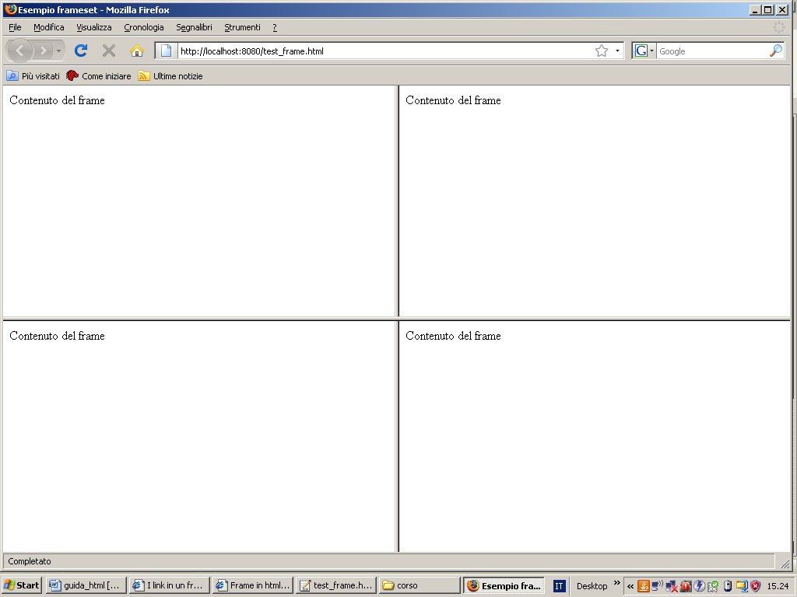
Picture 17

Using the tag <frameset> you create a set (a set) of frames. Each frame is specified by the tag <frame> followed by the src attribute that specifies the content of that frame. A particular frame is the frame named iframe (inline frame) which is nothing more than a frame that is made on the fly in the web page. In fact, the traditional frame is created in a page set up, ie in a cha page has the DTD (Document Type Definition) a frame structure. If you want to create a frame in a normal HTML page, which then has a normal structure, you must use the tag <iframe>. The syntax of an iframe is the same as the syntax of the frame, and the attributes are the same. Another mechanism for typesetting and enhancing your page style sheets (CSS (Cascading Style Sheets)). In essence, a style sheet is a file with the extension (CSS. CSS) that allows you to define, for example, the style must have a text, or a frame, or a table, or a grid of data visualization. Style sheets can be:

- Interior
- Exterior
The external style sheets can be safely inserted into the web page using the tag <link> followed by a series of attributes. For example, the rel attribute allows you to define the type of relationship between the document and the CSS file. This attribute is mandatory and there are basically two possible types of values:

- Stylesheet
- Alternate stylesheet
By the href attribute specifies the name of the CSS file to be included in the document (and is also required), while the type attribute specifies the data type to be connected. It 'mandatory, and always takes the value text / css.

<link rel="stylesheet" type="text/css" href="stile.css">
The HTML instruction is always inserted between the two <head> </ head>. E 'can also insert a style sheet in the HTML document using the tag <STYLE>, as shown below:

<html>
<head>
<title>Esempio foglio stile</title>
<style type="text/css">
body
{
background: #808080;
}
</style>
</head>
<body>
Esempio
</body>
</html>
As can be seen the code begins with the opening of the tag <style>. It can have two attributes:
1. type (obbligatory)
2. media (optional)
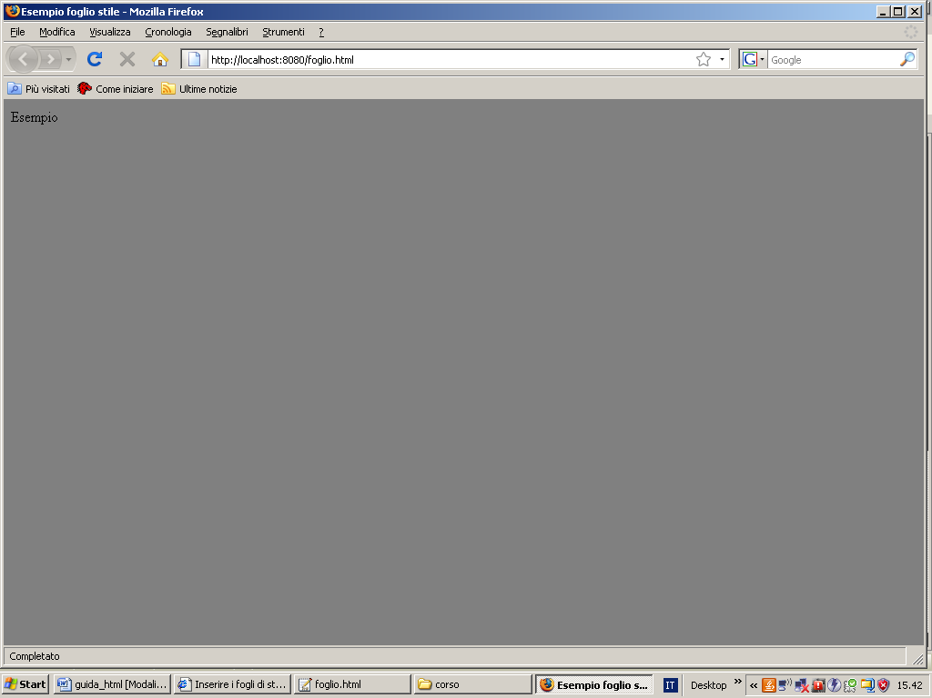
Picture 18

Now let's see how it is done essentially a style sheet. First, a style sheet is nothing more than a sheet of rules. Each rule consists of:

- A selector
- A declaration block

A selector is used to define the block of the document in which the rule applies. For example, s you want to display a particular red text in an HTML document, then you label <R> the code snippet affected by the change, and then specify all the rules that this fragment must be assogettato. The rules are specified within a pair of braces, and each rule is separated by a semicolon. For example:
<R>{rule name:value;rule name:value;…}
Let's see an example:
body {color background: #808080;}
We want the body (body) of our document has a gray background color. Therefore with style sheets you can assign to each tag in your document style note, which is a format, a particular color, and so on. Now let's see some basic types of switches:

- Selectors of elements, which is the simplest picker. In essence, you specify a style for a tag. The above example showed the use of a selector of this type.
- Universal selector, denoted by *, selects all the elements of a document.
3. Selector attribute, which allows you to select elements based on their attributes. For example:
input [id] {background: red;}
So basically you write:
element [attribute]

Another important concept is the concept of form. A form is a form of data collection to be sent to the server. Consider, for example, the masks for entering data. To create a form, you must use the <form>. The following example shows the creation and use of a form:
<!DOCTYPE HTML PUBLIC "-//W3C//DTD HTML 4.0 Transitional//EN">
<HTML><HEAD>
<META http-equiv=Content-Type content="text/html; charset=iso-8859-1">
<TITLE>Codice esempio Form </TITLE>
</HEAD>
<BODY>
<FORM name=newseditor action=inserimento.php method=post>
<FIELDSET class=notizia>
<LEGEND>Elementi:</LEGEND>
<BR><LABEL for=titolo>Titolo:</LABEL>
<INPUT class=testo id=titolo size=60
name=titolo><BR><BR><LABEL for=categoria>Valori:</LABEL><BR>
<INPUT id=categoria type=radio name=categoria> Valore1 <BR>
<INPUT id=categoria type=radio name=categoria> Valore2 <BR>
<INPUT id=categoria type=radio name=categoria> Valore3 <BR><BR>
<LABEL for=testo>Testo</LABEL>
<TEXTAREA class=testo id=testo name=testo rows=10 cols=55>Inserisci qui il corpo del messaggio</TEXTAREA>
</FIELDSET>
<FIELDSET class=submit><INPUT title=invia type=submit value=invia> </FIELDSET>
</FORM></BODY></HTML>

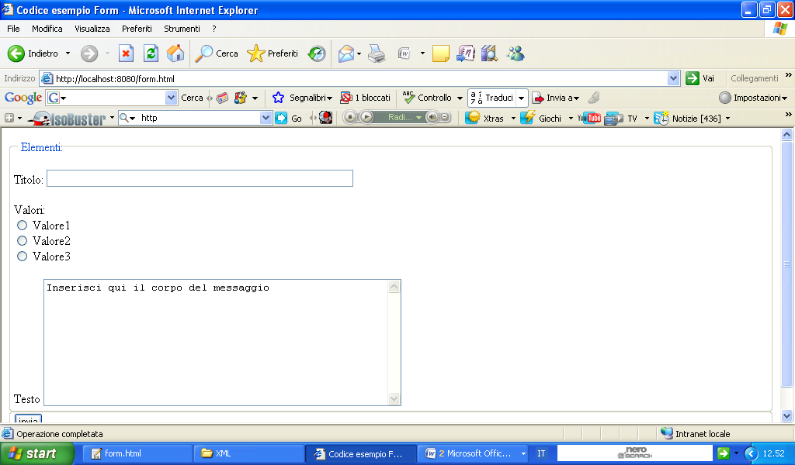
Picture 19
Let's see what's new. First in <form> there are some attributes more or less important. First, the name attribute specifies the name of the form, so that, in the event that there are multiple forms on the same HTML page, it is possible to identify a uniquely a form relative to another. The action attribute allows to invoke the script that will handle the data entered into the form in question. The method attribute instead to specify the method by which the data are propagated. In this case, you must provide a brief description of how the http protocol. First of http stands for Hyper Text Transfer Protocol, which is a protocol for transferring hypertext (HTML pages). This protocol works with a mechanism client / server ie with a mechanism of request / response. The client sends a request for an HTML page and the server responds with the content of the page. Therefore there are two types of http messages:
- Request message;
- Response message;
The request message is composed from:
- Request row;
- Header section;
- Body;
In turn, the request line is composed of:
- Method;
- URI;
- Protocol, version;
The method is the http method used for the data transfer. The two most commonly used methods are:
- Get;
- Post;
The GET method is used when you want to get the contents of a particular resource request, while the POST method is used to send information to the server. The URI stands for Uniform Resource Identifier, indicating the subject of the request. Finally, the version indicates the version of the HTTP protocol used. As regards the section header there are two possible values​​:
- Host;
- User Agent;
Even the response message is structured according to a specific format. In particular, the response message is composed of:
- State row;
- Header;
- Body;
The status line of the notification, the status of the request. More precisely, the status line presents a whole series of codes, each of which has a precise meaning. For example, the code that starts with a 4, it is an error code to the client, that the request can not be satisfied because it is wrong. For example, when you browse the Internet and displayed on the screen a message with code 404, means that the page was not found. We return now to the HTML code from the last example shown here. The first new tag is <FIELDSET>, which allows you to group a set of tools for user input (select box, radio box, ...). The tag <label> and <LABEL> provide static views of a precise portion of the page, while other tags are used to create input fields for the user. Let us now consider these fields. First, with the statement:
<INPUT id=categoria type=radio name=categoria> Valore1 <BR>
You create a radio box of the following type:
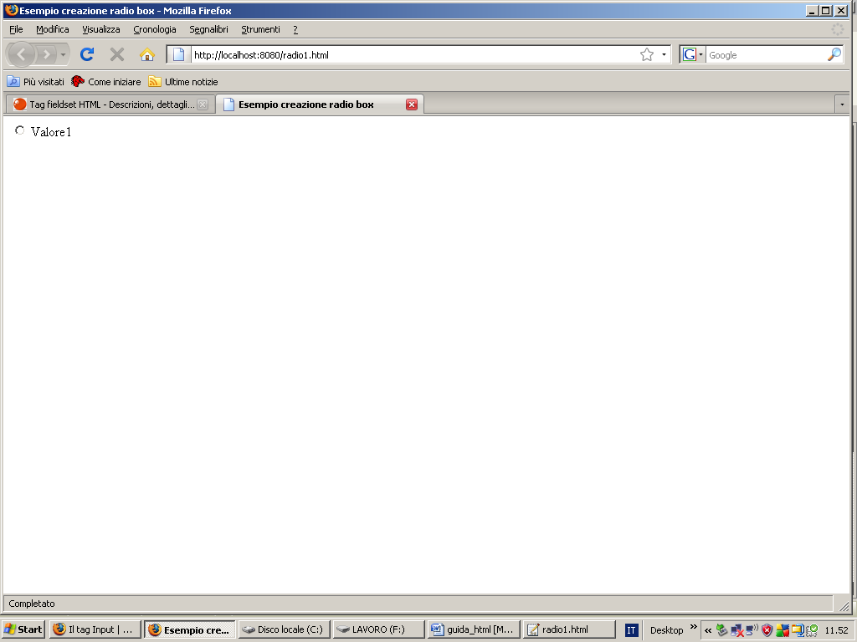
Picture 20
With the following statement instead you create a check box:
<INPUT Id=categoria type=checkbox name=categoria> Value1 <BR>
Similarly, you can create a text box and a textarea. In particular the textarea allows to generate an area where the user can safely enter the message. To create a textbox and a textarea using following tags:
<INPUT Id=categoria type=textbox name=categoria> Value1 <BR>
<TEXTAREA Class=testo id=testo name=testo rows=10 cols=15> </ TEXTAREA>

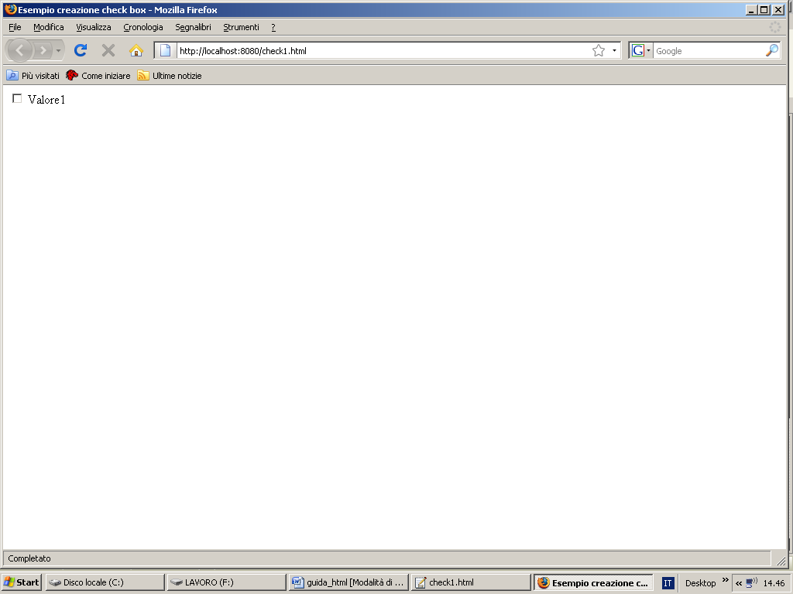
Picture 21
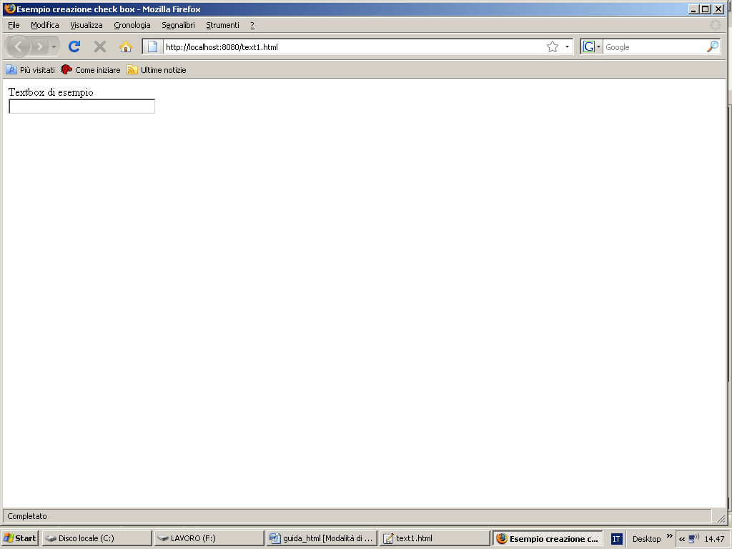
Picture 22

Up to this point we have discussed pure HTML. Now we see a natural extension of HTML, or XHTML. First, the 'XHTML is nothing but the union of two technologies:
XHTML = HTML + XML
Of 'HTML we have spoken. Let us now briefly analyze the 'XML. First, XML stands for eXtensible Markup Language and is a markup language that allows you to create a specific format for the data. With XML, you can also create new custom tag, as opposed to the normal HTML where the tags are fixed. An XML file has the extension (. XML). Let's see an example:

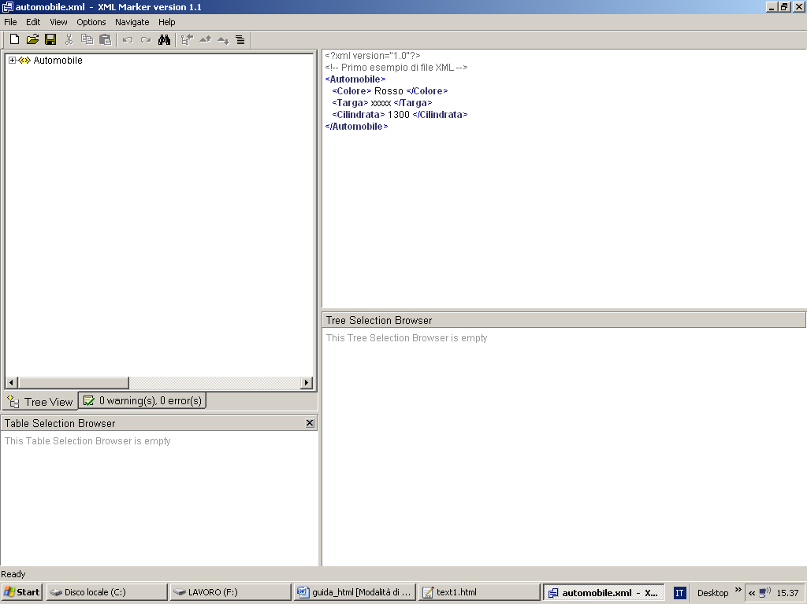
Picture 23
The figure shows a close-trivial example of the XML file. Such files, being a purely textual files, can be written with any text editor, although commercially available editors are more sophisticated such as for example XML Marker. Rewrite the XML:

<?xml version="1.0"?>
<!-- Primo esempio di file XML -->
<Automobile>
<Colore> Rosso </Colore>
<Targa> xxxxx </Targa>
<Cilindrata> 1300 </Cilindrata>
</Automobile>
The first line is the processing instruction and basically represents me the XML version used. The second line is a comment. Comments in XML are the same as comments in HTML. The tag <automobile> instead I was a main element (root element) in the XML document. At this point there is a clear need to provide a brief description of the main "actors" present in an XML file.
- Elements
- Attributes
- Comments
- CDATA section
- Processing istruction
- Entity
- Type document declaration
Analyze what is the item. In an XML document element is the basic object for data representation. In the previous example the car is an element, and being the main element is also said root element. An attribute instead describes me something more about the item. For example, if we have a <Person> tag, this tag can have attributes like sex. So you can have a situation of the following type:
<persona sesso=”Maschio”>
<Nome>Marco</Nome>……
</persona>
An XML document is important that:
- Valid
- Well formed
First you have to specify the meaning of these two terms. With valid means an XML document that follows certain rules, ie if it contains syntax errors and tags are all balanced (opened and subsequently closed). If a document also complies with the structural requirements specified in the DTD, then the XML document is valid. The DTD (Document Type Definition) is a document that describes in detail each item and size of the XML document. A DTD can be internal or external to the XML document to the XML document. Let's see an example of a document within which you define a DTD:
<?xml version="1.0"?>
<!-- Primo esempio di file XML -->
<!DOCTYPE Automobile [<!ELEMENT identificativo (Colore, targa, Cilindrata)>
<!ELEMENT Colore (#PCDATA)>
<!ELEMENT Targa (#PCDATA)>
<!ELEMENT Cilindrata(#PCDATA)> ]>
<Automobile>
<Colore> Rosso </Colore>
<Targa> xxxxx </Targa>
<Cilindrata> 1300 </Cilindrata>
</Automobile>
Using the <! DOCTYPE> specify the internal DTD. You specify the various attributes of each element, and the type of acceptable data (PCDATA = data type character). If the DTD is external, then the same is to be clearly included within the XML document. Lìuso the external DTD involves writing rules in a file with an extension DTD. For example:
<?xml version="1.0"?>
<!-- Primo esempio di file XML -->
<!DOCTYPE automobile SYSTEM "auto_regole.dtd">
<Automobile>
<Colore> Rosso </Colore>
<Targa> xxxxx </Targa>
<Cilindrata> 1300 </Cilindrata>
</Automobile>
With the following external DTD:

<!DOCTYPE Automobile [<!ELEMENT identificativo (Colore, targa, Cilindrata)>
<!ELEMENT Colore (#PCDATA)>
<!ELEMENT Targa (#PCDATA)>
<!ELEMENT Cilindrata(#PCDA
Stored in the file auto_regole.dtd. Having said that we have concluded this brief overview of the XML language. Let's talk about XHTML. It 's already been mentioned that XHTML is the "fusion" of two technologies: HTML and XML. In an XHTML document is easily possible to use scripts written for example in PHP5 or Javascript. Let's see, for example, an XHTML page that uses a JavaScript script (for guidance on Javascript and PHP5 I invite you to read the appropriate manual from me hanging freely downloadable at my site):
<!DOCTYPE html PUBLIC "-//W3C//DTD XHTML 1.0 Strict//EN"
"http://www.w3.org/TR/xhtml1/DTD/xhtml1-strict.dtd">
<html xmlns="http://www.w3.org/1999/xhtml">
<head>
<title>Esempio di script</title>
</head>
<script language="javascript">
alert("Primo script di prova!!!");
</script>
<body>
</body>
</html>
As you can easily notice the XHTML page contains the SCRIPT tag that allows you to enclose the script. The LANGUAGE parameter allows you to specify the programming language used to create the script. In this case, the programming language is JavaScript. The script, in this case, video printing the message: “Primo script di prova!!!”.

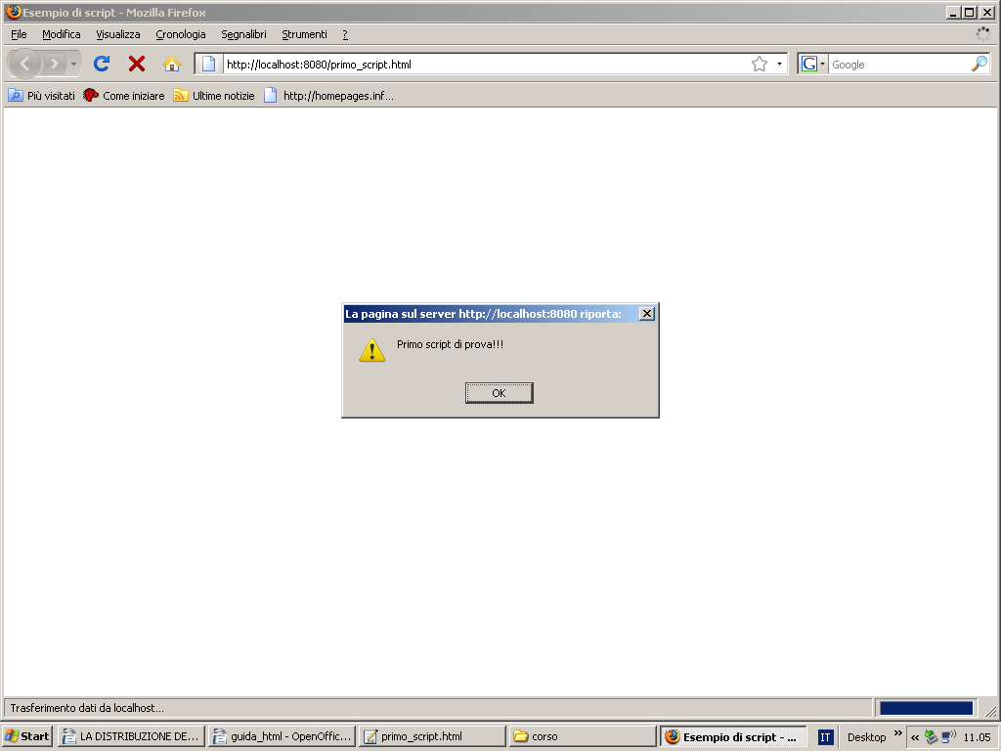
Picture 24
If we wanted to add a Visual Basic script we should simply write:
LANGUAGE=”vbscript”
So a script is a piece of code written in some programming language, interpreted by the browser, which allows you to make dynamic web page itself. Let us consider the following code that uses instead a PHP script embedded in a web page (stored in turn as a PHP file):
<!DOCTYPE html PUBLIC "-//W3C//DTD XHTML 1.0 Strict//EN"
"http://www.w3.org/TR/xhtml1/DTD/xhtml1-strict.dtd">
<html xmlns="http://www.w3.org/1999/xhtml">

<head>
<title>Primo script PHP</title>
</head>
<body>
<?php
echo 'primo script php';
?>
</body>
</html>
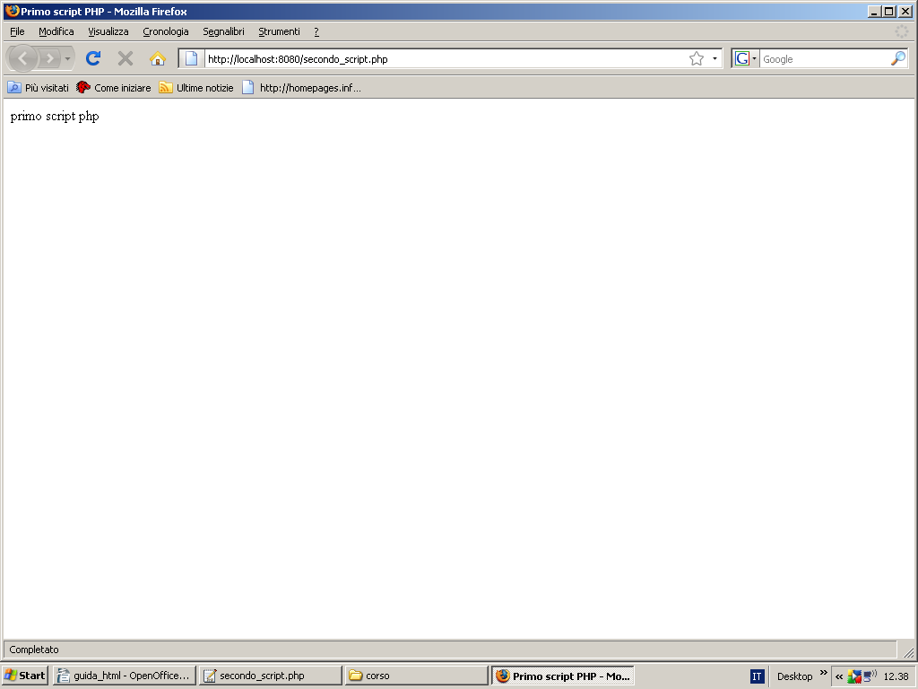
Picture 25

For further information on JavaScript and PHP5, I recommend studying one player to the manuals (over the course of JavaScript and PHP) on my site.

